Review Sheet

1. Line segemnt PT has endpoints whose coordinates are P(-2,1) and T (4,7). Determine the coordinates of point J that divides the segment in the ratio 2:1. [the use of the accompanying grid is optional]

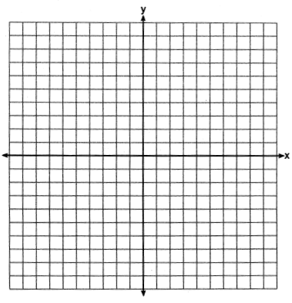

1. Which shape does ***not*** have rotational symmetry?

(1) trapezoid (2) regular pentagon (3) circle (4) square

3. A polygon is transformed according to the vector <2,0>. Every point of the polygon moves two units which way?

1. up (2) down (3) left (4) right

4. How many lines of symmetry does the accompanying figure have?



(1) an infinite number (3) 8

(2) 2 (4) 4

1. Divide the line segment into a 1:3 ratio.

6. Triangle *ABC* has vertices , , and . Under a translation, , the image point of *A*, is located at . Under this same translation, what are the coordinates of point ?

1. Use a compass and straightedge to translate the given triangle. Use the given vector to perform the translation.

8.

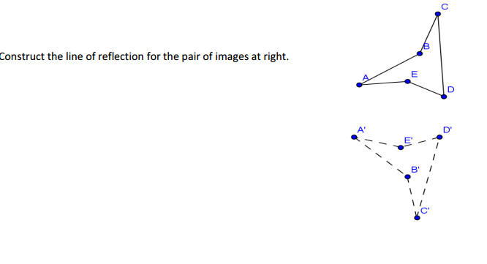

1. Triangle *XYZ*, is reflected over the line . State the coordinates of , the image of .

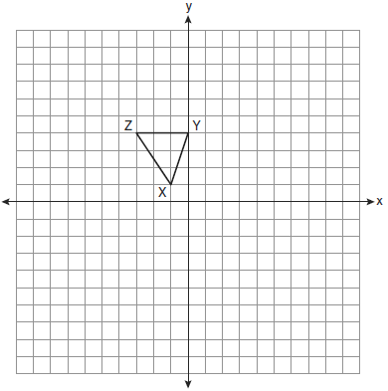

10.

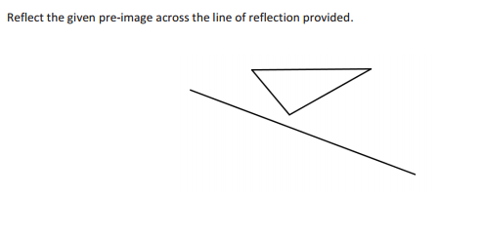

11. Trapezoid MNOP is plotted on the grid below. Draw the image of trapezoid MNOP after a reflection over the *y* -axis. Label the new trapezoid M’N’O’P’. Explain how you determined the location of point M’.



1. Melissa drew the shape on the grid shown below. Draw the reflection of this shape in the *x*-axis.



1. Gary drew a triangle on the coordinate grid shown below. If Gary reflects the triangle in the line y = x, what will be the new coordinates of the vertices of the triangle?



1. Triangle *SUN* has coordinates *S*(0,6), *U*(3,5), and *N*(3,0). On the accompanying grid, draw and label ∆*SUN*. Then, graph and state the coordinates of ∆*S**U**N*, the image of ∆*SUN* after a reflection in the y = -4.

**

1. On the accompanying set of axes, draw the reflection of *ABCD* in the line y = -x. Label and state the coordinates of the reflected figure.

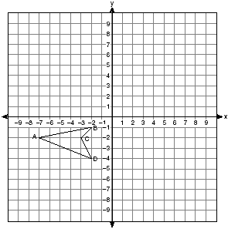

16. The coordinates of the vertices of quadrilateral ABCD are A(3, -3), B(6, 1), C(3, 2), and D(1,2).

1. Graph quadrilateral ABCD.
2. Graph and state the coordinates of the vertices of quadrilateral A’B’C’D’, the image of ABCD under .
3. Draw a vector illustrating this translation.
4. Write the rule of the translation as a vector in component form.

**